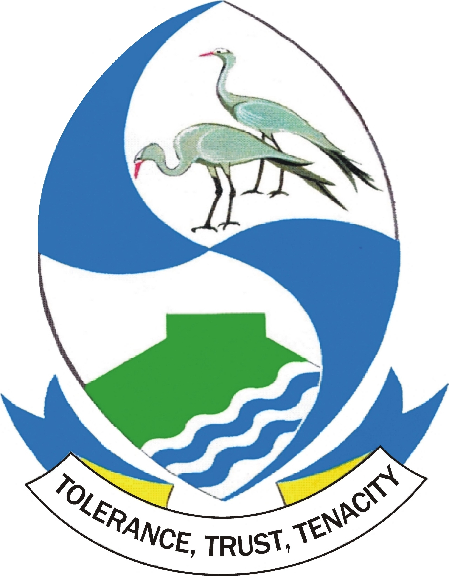
BLUE CRANE ROUTE MUNICIPALITY

NOTICE NO 26/2021

ORDINARY COUNCIL MEETING – 29 JULY 2021

Notice is hereby given in terms of Section 19(a) of the Local Government Municipal Systems Act, Act No 32 of 2000, that an Ordinary Council Meeting of the Blue Crane Route Municipality will be held as detailed below:-

Date : Thursday, 29 July 2021
Venue : Microsoft Teams (Virtual - Link to be obtained from Manager: ICT)
Time : 10:00
In terms of Section 20(1) of the Municipal Systems Act, members of the public, the media and other interested parties or bodies are invited to attend the meeting. Kindly contact the Manager: ICT, Mr M. Gush, at cell no 082 899 4555 or email ictofficer@bcrm.gov.za, for the link to connect to the Meeting.

SOMERSET EAST THABISO KLAAS
20/07/2021 MUNICIPAL MANAGER
67 Nojoli Street
P.O. Box 21
SOMERSET EAST
5850
Tel : 042 243 6400
Fax : 042 243 3392
Email : mmanager@bcrm.gov.za

